ROHM Switching Regulator Solutions

Evaluation Board:

7.5V to 15V, 4A Integrated MOSFET

1ch Synchronous Buck DC/DC Converter

BD95841MUVEVK-101 (3.3V | 4A Output)

No.000000000

* Introduction

This application note will provide the steps necessary to operate and evaluate ROHM’s synchronous buck DC/DC converter using the BD95841MUV evaluation boards. Component selection, board layout recommendations, operation procedures and application data is provided.

* Description

This evaluation board has been developed for ROHM’s synchronous buck DC/DC converter customers evaluating BD95841MUV. While accepting a wide power supply of 7.5-15V, an output of 0.8V to 5.5V can be produced. The IC has internal 65mΩ high-side Nch MOSFET and 45mΩ low-side Nch MOSFET and a synchronization frequency range of 500 kHz to 800 kHz. A fixed Soft Start circuit prevents in-rush current during startup along with UVLO (low voltage error prevention circuit) and TSD (thermal shutdown detection) protection circuits. An EN pin allows for simple ON/OFF control of the IC to reduce standby current consumption. Include open-drain PGOOD feature for operation indication, OCP, SCP and OVP.

* Applications

LCD TVs

Set Top Boxes (STB)

DVD/Blu-ray players/recorders

Broadband Network and Communication Interface

Amusement, other

* Evaluation Board Operating Limits and Absolute Maximum Ratings (TA=25oC)

|  |  |  |  |  |  |  |  |
| --- | --- | --- | --- | --- | --- | --- | --- |
| **Parameter** | | **Symbol** | **Limit** | | | **Unit** | **Conditions** |
| **MIN** | **TYP** | **MAX** |
| **Supply Voltage** | | | | | | | |
|  | BD95841MUV | V­CC | 7.5 | - | 15 | V |  |
| **Output Voltage / Current** | | | | | | | |
|  | BD95841MUV | VOUT | 0.8 | - | 5.5 | V | * Set by R2,R3 and R4 |
| IOUT | - | - | 4 | A |  |

* Evaluation Board

Below is evaluation board with the BD95841MUV.

**Vout**

**GND**

**EN**

BD9673EFJ Eval Board

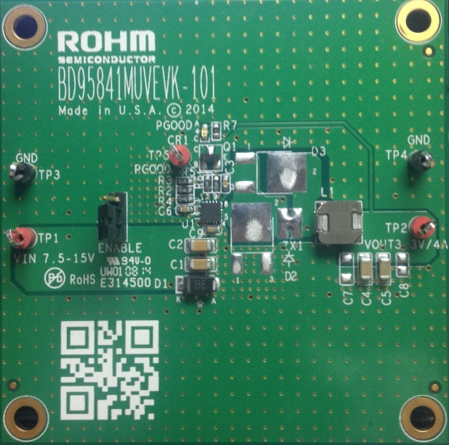

Fig 1: BD95841MUV Evaluation Board

* Evaluation Board Schematic

Below is evaluation board schematic for BD95841MUV.

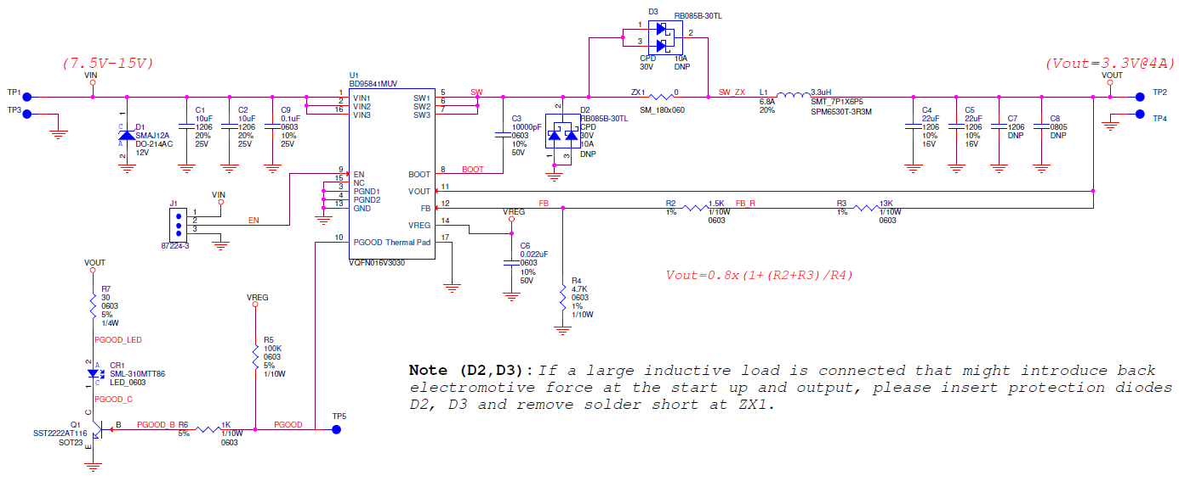

Fig 2: BD95841MUV Evaluation Board Schematic

* Evaluation Board I/O

Below is reference application circuit that shows the inputs (VIN, EN) and the output (VOUT, PGOOD).

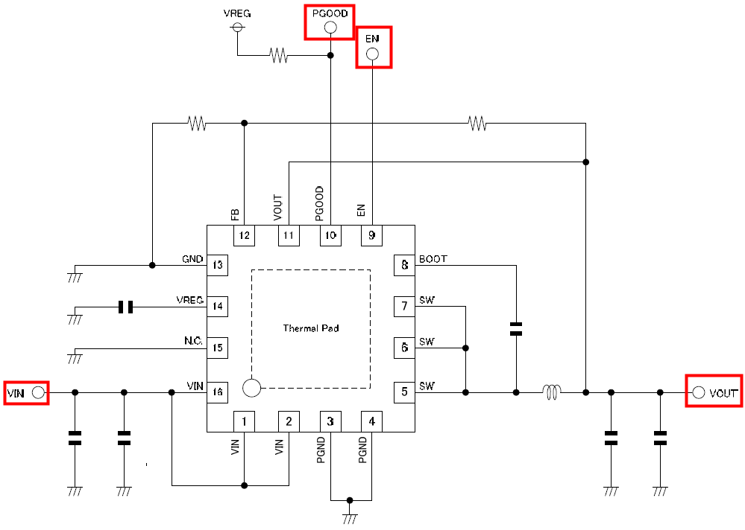

Fig 3: BD95841MUV Evaluation Board I/O

* Evaluation Board Operation Procedures

Below is the procedure to operate the evaluation board.

1. Connect power supply’s GND terminal to GND test point TP3 on the evaluation board.
2. Connect power supply’s VCC terminal to VIN test point TP1 on the evaluation board. This will provide VIN to the IC U1. Please note that the VCC should be in range of 7.5V to 15V.
3. Check if shunt jumper of J1 is at position ON (Pin2 connect to Pin1, EN pin of IC U1 is pulled high as default).
4. Now the output voltage VOUT (+3.3V) can be measured at the test point TP2 on the evaluation board with a load attached. The load can be increased up to 4A MAX.

* Reference Application Data for BD95841MUVEVK-101

Following graphs show hot plugging test, quiescent current, efficiency, load response, output voltage ripple response of the BD95841MUV evaluation board.

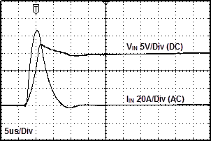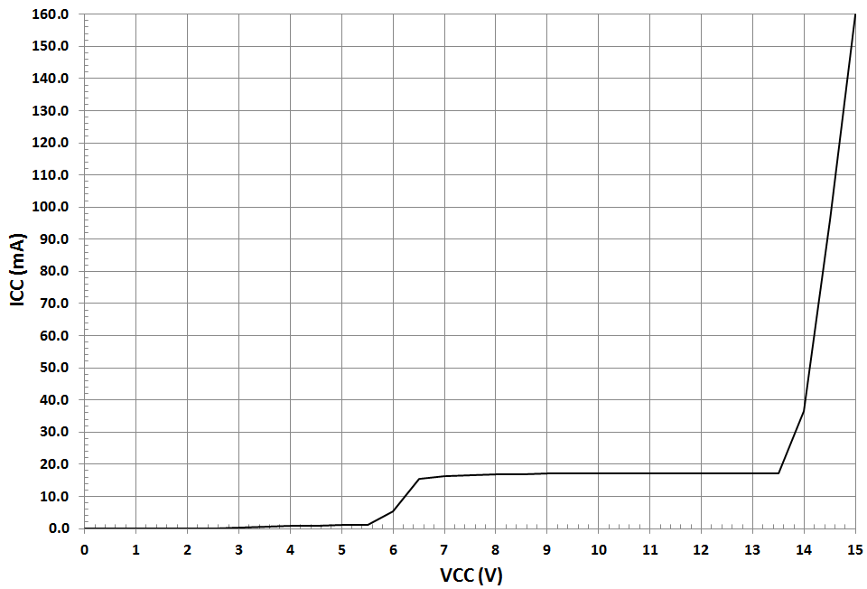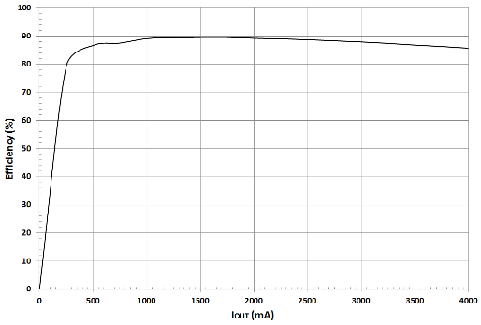

**Fig 4: Hot Plug-in Test with Zener Diode SMAJ12A, VIN=15V, VOUT=3.3V, IOUT=4A**

**Fig 5: Circuit Current vs. Power supply Voltage Characteristics (Temp=25oC)**

**Fig 6: Electric Power Conversion Rate**

**(VIN=12V, VOUT=3.3V)**

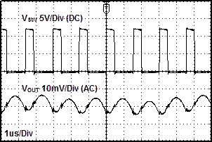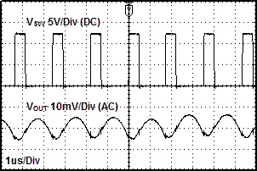

Fig 9: Output Voltage Ripple Response Characteristics

(VIN=12V, VOUT=3.3V, L=3.3uH, COUT=22uFx2, IOUT=0A)

Fig 10: Output Voltage Ripple Response Characteristics

(VIN=12V, VOUT=3.3V, L=3.3uH, COUT=22uFx2, IOUT=4A)

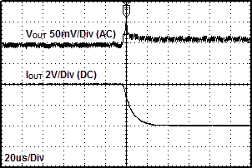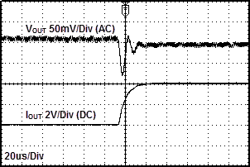

Fig 7: Load Response Characteristics

(VIN=12V, VOUT=3.3V, L=3.3uH, COUT=22uFx2, IOUT=0A🡪4A)

Fig 8: Load Response Characteristics

(VIN=12V, VOUT=3.3V, L=3.3uH, COUT=22uFx2, IOUT=4A🡪0A)

* Evaluation Board Layout Guidelines

Two high pulsing current flowing loops exist in the buck regulator system.

The first loop, when FET is ON, starts from the input capacitors, to the VIN terminal, to the SW terminal, to the inductor, to the output capacitors, and then returns to the input capacitor through GND.

The second loop, when FET is OFF, starts from the low FET, to the inductor, to the output capacitor, and then returns to the low FET through GND.

To reduce the noise and improve the efficiency, please minimize these two loop area.

Especially input capacitor and output capacitor should be connected to GND (PGND) plain.

PCB Layout may affect the thermal performance, noise and efficiency greatly. So please take extra care when designing PCB Layout patterns.

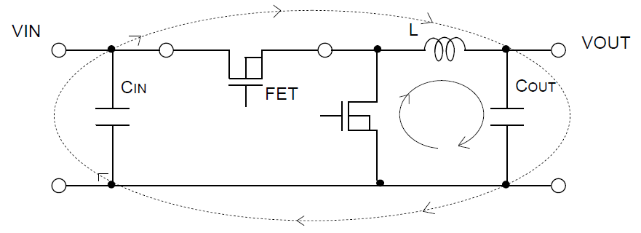

Fig 11: Current loop Buck regulator system

* The thermal Pad on the back side of IC has the great thermal conduction to the chip. So using the GND plain as broad and wide as possible can help thermal dissipation. And a lot of thermal via for helping the spread of heat to the different layer is also effective.
* The input capacitors should be connected to PGND as close as possible to the VIN terminal.
* The inductor and the output capacitors should be placed close to SW pin as much as possible.

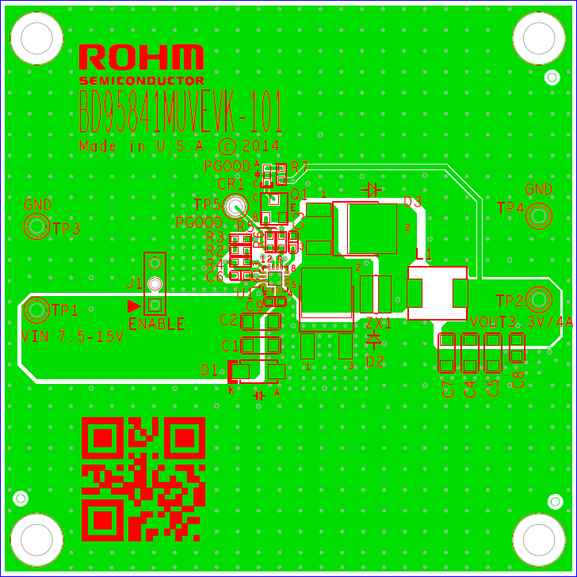

Fig 12: BD95841MUVEVK-101 Board PCB layout

Additional layout notes:

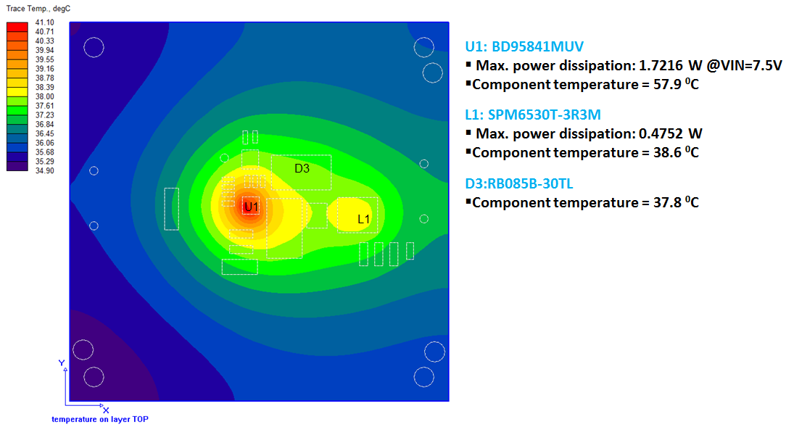

Fig 13: BD95841MUVEVK-101 Thermal Characteristics at Temp=25oC, no air flow, VIN=7.5V, VOUT=3.3V, IOUT=4A and D3 not installed

* The thermal Pad on the back side of IC has the great thermal conduction to the chip. So using the GND plane as broad and wide as possible can help thermal dissipation. And a lot of thermal via for helping the spread of heat to the different layer is also effective.
* The input capacitors should be connected to PGND as close as possible to the VIN terminal.
* The inductor and the output capacitors should be placed close to SW pin as much as possible.
* For applications operating at or near maximum voltage conditions (18V max), additional precautions regarding heat dissipation need to be considered during board layout. The provided evaluation board is a 4-layer board meant for evaluation purposes only. At maximum conditions, the IC’s internal thermal shutdown detection circuit will be potentially initiated and the output disabled until the junction temperature falls. For final designs operating near these conditions, we recommend using one of the below PCB options for better heat dissipation of the IC.

1. Use of a 4-layer PCB with internal GND planes connected to the IC GND pins.
2. Use of a 2-layer PCB with a heat sink attached to the IC package.
3. Use of a 2-layer PCB with a copper plane (>1oz) attached to the IC.

* Calculation of Application Circuit Components

1. Output LC Filter Selection (Buck Converter)
   1. Inductor (L) Selection

The Output LC filter is required to supply constant current to the output load. A larger value inductance at this filter results in less inductor ripple current (ΔIL) and less output ripple voltage. However, the larger value inductors tend to have less fast load transient-response, a larger physical size, a lower saturation current and higher series resistance. A smaller value inductance has almost opposite characteristics above.

The value of ΔIL is shown as formula (1). The larger value of the inductance or the faster switching frequency makes the lower ripple voltage.

(1)

The proper output ripple current setting is about 30% of maximum output current.

(2)

(3)

(∆IL: output ripple current, f: switching frequency)

* A larger current than the inductor’s rated current will cause magnetic saturation in the inductor, and decrease efficiency. When selecting an inductor, be sure to allow enough margins to assure that peak current does not exceed the inductor’s rated current value.
* To minimize loss of inductor and improve efficiency, choose a inductor with a low resistance (DCR, ACR).

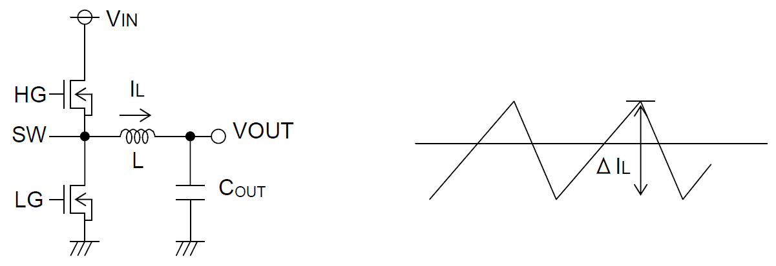

Fig 14: Inductor Ripple Current

* 1. Output Capacitor (COUT) Selection

Output Capacitor (COUT) has a considerable influence on output voltage regulation due to a rapid load change and smoothing output ripple voltage. Determine the capacitor by considering the value of capacity, the equivalent series resistance, and equivalent series inductance. Also, make sure the capacitor’s voltage rating is high enough for the set output voltage (including ripple).

Output ripple voltage is determined as in formula (4) below.

(4)

(∆IL: Output ripple current, ESR: Equivalent series resistance, ESL: Equivalent series inductance)

Also, give consideration to the conditions in formula (5) below for output capacitance, bearing in mind that output rise time must be established within the fixed soft start time. As output capacitance, bypass capacitor will be also connected to output load side (CEXT, Fig.14). Please set the over current detection value with regards to these capacitance.

(5)

(IOCP: OCP Current Limit, IOUT: Output Current)

Note: an improper output capacitor may cause startup malfunctions.

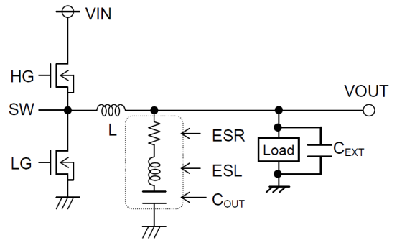

Fig 15: Output Capacitor

1. Input Capacitor (CIN) Selection

In order to prevent transient spikes in voltage, the input capacitor should have a low enough ESR resistance to fully support a large ripple current. The formula for ripple current IRMS is given in formula (6) as below.

(6)

A low ESR capacitor is recommended to reduce ESR loss and improve efficiency.

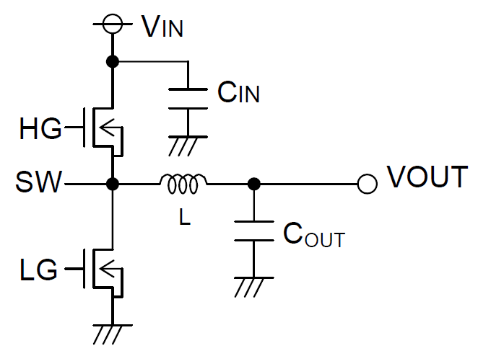

Fig 16: Input Capacitor

1. Output Voltage Setting

The IC controls output voltage as REF≒VFB.

However, the actual output voltage will also reflect the average ripple voltage value.

The output voltage is set with a resistor divider from the output node to the FB pin. The formula for output voltage is given in formula (7) below:

(7)

(8)

(9)

Please refer to formula (4) regarding ΔVOUT.

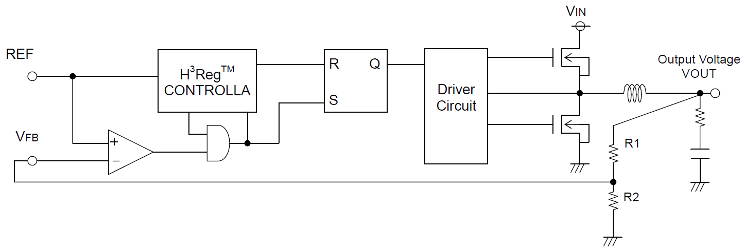

Fig 17: Output Voltage Setting

1. Relationship between Output Voltage and ONTIME

BD95841MUV is a synchronous buck converter controlling constant ON TIME. The ONTIME (TON) depends on the output voltage settings, as described by the formula (10).

(10)

The frequency of the application condition is determined by the formula (11) using the above TON.

(11)

However with actual applications, there exists a rising and falling time of the SW due to the gate capacitance of the integrated MOSFET and the switching speed, which may vary the above parameters. Therefore please also verify those parameters experimentally.

1. Relationship between Output Current and Frequency

BD95841MUV is a constant ontime type of switching regulator. When the output current increases, the switching loss of the inductor, MOSFET, and output capacitor also increases. Hence the switching frequency speeds up.

The loss of the inductor, MOSFET, and output capacitor is determined as below.

(DCR: Inductor Equivalent series resistance, RONH: On resistance of High-side MOSFET, RONL: On resistance of Low-side MOSFET, ESR: COUT Equivalent series resistance)

Taking the above losses into the frequency equation, then T (=1/Freq) becomes

(12)

However since the parasitic resistance of the PCB layout pattern exists in actual applications and affects the parameter, please also verify experimentally.

* Evaluation Board BOM

Below is a table with the build of materials. Part numbers and supplier references are provided.

|  |  |  |  |  |  |
| --- | --- | --- | --- | --- | --- |
| **Item** | **Qty.** | **Ref** | **Description** | **Manufacturer** | **Part Number** |
| 1 | 1 | CR1 | LED 570NM GREEN WTR CLR 0603 SMD | Rohm | SML-310MTT86 |
| 2 | 2 | C1,C2 | CAP CER 10UF 25V 20% X5R 1206 | Murata | GRM31CR61E106MA12L |
| 3 | 1 | C3 | CAP CER 10000PF 50V 10% X7R 0603 | Murata | GRM188R71H103KA01D |
| 4 | 2 | C4,C5 | CAP CER 22UF 16V 10% X5R 1206 | Murata | GRM31CR61C226KE15K |
| 5 | 1 | C6 | CAP CER 0.022UF 50V 10% X7R 0603 | Murata | GRM188R71H223KA01D |
| 6 | 1 | C9 | CAP CER 0.1UF 25V 10% X7R 0603 | Murata | GRM188R71E104KA01D |
| 7 | 1 | D1 | TVS DIODE 12VWM 19.9VC SMA | Littelfuse Inc | SMAJ12A |
| 8 | 1 | J1 | CONN HEADER VERT .100 3POS 15AU | TE Connectivity Div | 87224-3 |
| 9 | 1 | L1 | INDUCTOR 3.3UH 6.8A 20% SMD | TDK Corporation | SPM6530T-3R3M |
| 10 | 1 | Q1 | TRANSISTOR NPN 40V 0.6A SOT-23 | Rohm | SST2222AT116 |
| 11 | 1 | R2 | RES 1.5K OHM 1/10W 1% 0603 SMD | Rohm | RHM1.5KBJTR-ND |
| 12 | 1 | R3 | RES 13K OHM 1/10W 1% 0603 SMD | Rohm | MCR03ERTF1302 |
| 13 | 1 | R4 | RES 4.7K OHM 1/10W 1% 0603 SMD | Rohm | MCR03ERTF4701 |
| 14 | 1 | R5 | RES 100K OHM 1/10W 5% 0603 SMD | Rohm | MCR03ERTJ104 |
| 15 | 1 | R6 | RES 1K OHM 1/10W 5% 0603 SMD | Rohm | MCR03ERTJ102 |
| 16 | 1 | R7 | RES 30 OHM 1/10W 5% 0603 SMD | Rohm | ESR03EZPJ300 |
| 17 | 3 | TP1,TP2,TP5 | TEST POINT PC MULTI PURPOSE RED | Keystone Electronics | 5010 |
| 18 | 2 | TP3,TP4 | TEST POINT PC MULTI PURPOSE BLK | Keystone Electronics | 5011 |
| 19 | 1 | U1 | 7.5V to 15V, 4A 1ch Synchronous Buck Converter | ROHM | BD95841MUV |
| 20 | 1 |  | Shunt jumper for header J1 (item #8), CONN SHUNT 2POS GOLD W/HANDLE | TE Connectivity | 881545-1 |

**Notes**

No copying or reproduction of this document, in part or in whole, is permitted without the consent of ROHM Co.,Ltd.

The content specified herein is subject to change for improvement without notice.

The content specified herein is for the purpose of introducing ROHM's products (hereinafter "Products"). If you wish to use any such Product, please be sure to refer to the specifications, which can be obtained from ROHM upon request.

Examples of application circuits, circuit constants and any other information contained herein illustrate the standard usage and operations of the Products. The peripheral conditions must be taken into account when designing circuits for mass production.

Great care was taken in ensuring the accuracy of the information specified in this document. However, should you incur any damage arising from any inaccuracy or misprint of such information, ROHM shall bear no responsibility for such damage.

The technical information specified herein is intended only to show the typical functions of and examples of application circuits for the Products. ROHM does not grant you, explicitly or implicitly, any license to use or exercise intellectual property or other rights held by ROHM and other parties. ROHM shall bear no responsibility whatsoever for any dispute arising from the use of such technical information.

The Products specified in this document are intended to be used with general-use electronic equipment or devices (such as audio visual equipment, office-automation equipment, communication devices, electronic appliances and amusement devices).

The Products specified in this document are not designed to be radiation tolerant.

While ROHM always makes efforts to enhance the quality and reliability of its Products, a Product may fail or malfunction for a variety of reasons.

Please be sure to implement in your equipment using the Products safety measures to guard against the possibility of physical injury, fire or any other damage caused in the event of the failure of any Product, such as derating, redundancy, fire control and fail-safe designs. ROHM shall bear no responsibility whatsoever for your use of any Product outside of the prescribed scope or not in accordance with the instruction manual.

The Products are not designed or manufactured to be used with any equipment, device or system which requires an extremely high level of reliability the failure or malfunction of which may result in a direct threat to human life or create a risk of human injury (such as a medical instrument, transportation equipment, aerospace machinery, nuclear-reactor controller, fuel-controller or other safety device). ROHM shall bear no responsibility in any way for use of any of the Products for the above special purposes. If a Product is intended to be used for any such special purpose, please contact a ROHM sales representative before purchasing.

If you intend to export or ship overseas any Product or technology specified herein that may be controlled under the Foreign Exchange and the Foreign Trade Law, you will be required to obtain a license or permit under the Law.



Thank you for your accessing to ROHM product information.

More detail product information and catalogs are available, please contact us.

**ROHM Customer Support System**

<http://www.rohm.com/contact/>